Bot Workflow:
Verify State Licenses (nationwide)
- Contract is signed
  - Create PCD folder in K drive for the provider (Last Name, First Name)
Where to find license information:
- License field in PARCS
- Cred_onboarding@essenmed.com
- BHAPatel@Essenmed.com

- As soon as License field is filled out (in PARCS application) or documents sent via email:
- Go to: https://www.healthguideusa.org/medical_license_lookup.htm
- Click into specific State (based on License)
  - Dropdowns:
    - Search By: License Number
    - Profession: [Based on provider type]
      - Enter License Number: XXXXXX
- Click GO
- Click on License Number
- Take a screenshot of pop-up window for provider and download PDF with timestamp of date and time
- Save PDF into PCD folder and name the file: NY License Verification, Exp. xx.xx.xxxx
- Add to provider checklist
  - Include:
    - License State
    - Status
    - Date verified
    - Expiration date (Registered through Date)
License Example Photos:
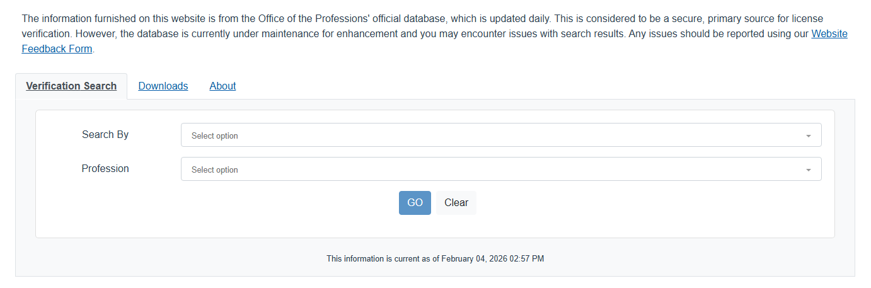
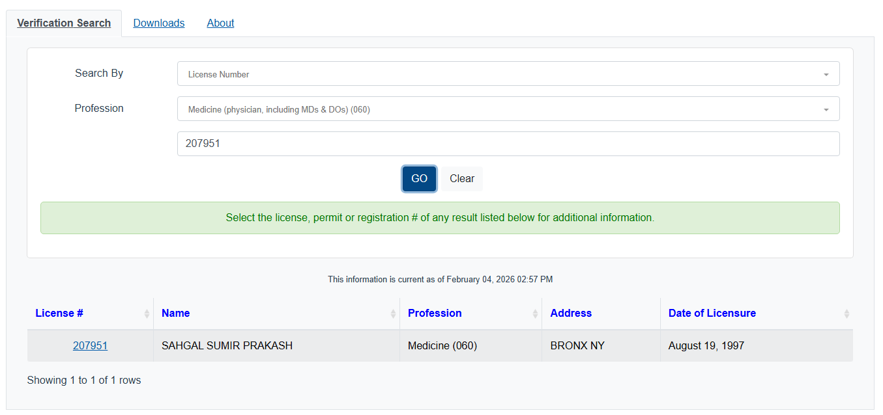
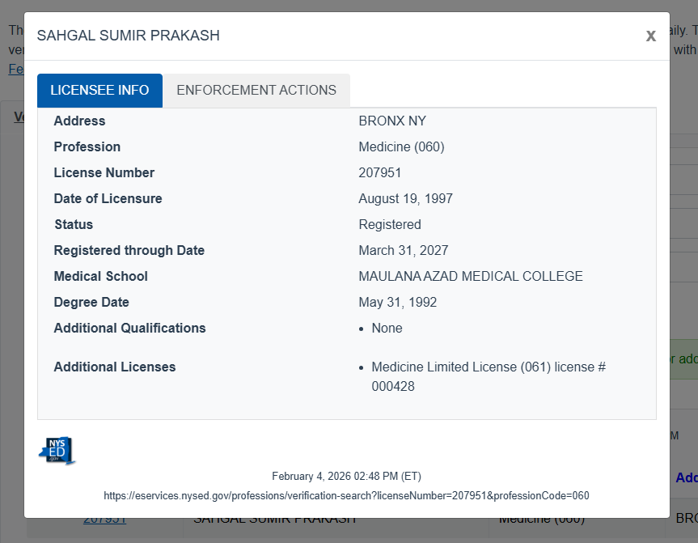
Verify DEA (nationwide)
- Requires MFA
Verify Boards
- For PA
  - Go to: https://portal.nccpa.net/verifypac
    - Enter:
      - First Name
      - Last Name
      - State
      - Country
  - Click Verify Board Certification
  - Click Email Document
    - Scroll Down and Enter:
      - Name of Organization: Essen Health Care
      - Full Name:
      - Email:
  - Download PDF received via email into provider’s PCD folder
    - Name the file: Boards Verification NCCPA exp xx.xx.xxxx
  - Add to provider checklist
    - Include:
      - ID #
      - Status
      - Date verified
      - Expiration date (“valid until”)
PA Boards Example Photos:
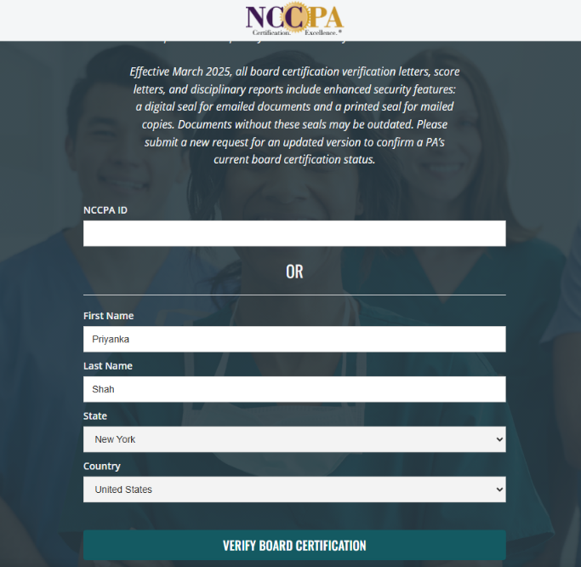
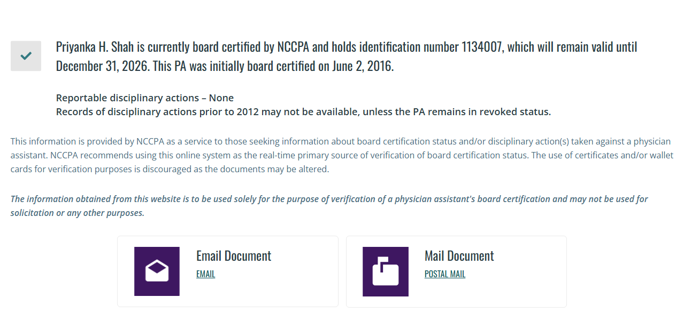
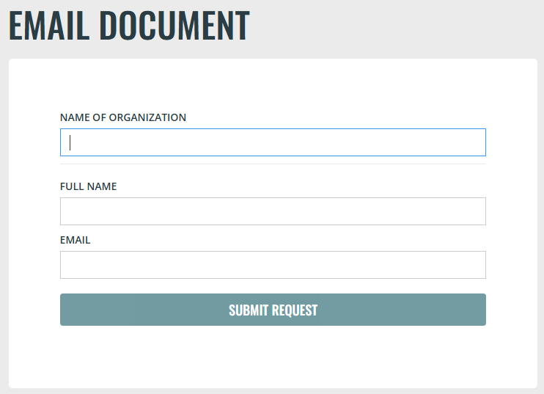
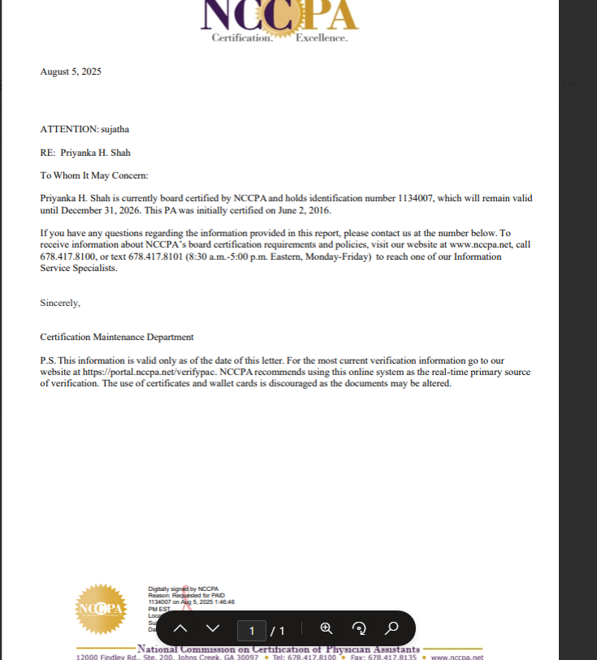

- For Physicians – ABIM (Internal Medicine & Subspecialties)
  - Go to: https://www.abim.org/verify-physician/
    - Click NPI
      - Enter NPI #
    - Click Search
    - Screen grab the full page to include website with date and timestamp
      - Format: PDF
    - Save PDF into provider’s PCD folder
      - Name the file: Boards Verification ABIM exp xx.xx.xxxx
  - Add to provider checklist
    - Include:
      - ABIM ID #
      - Status
      - Date verified
ABIM Boards Example Photos:
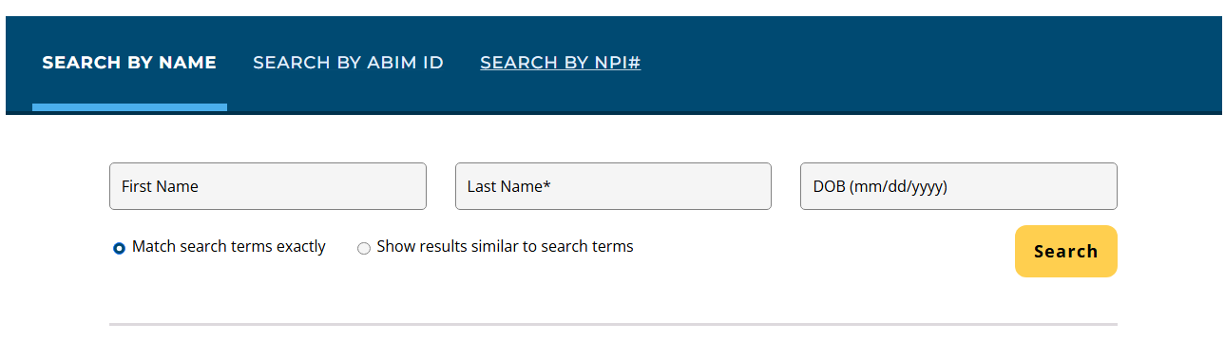
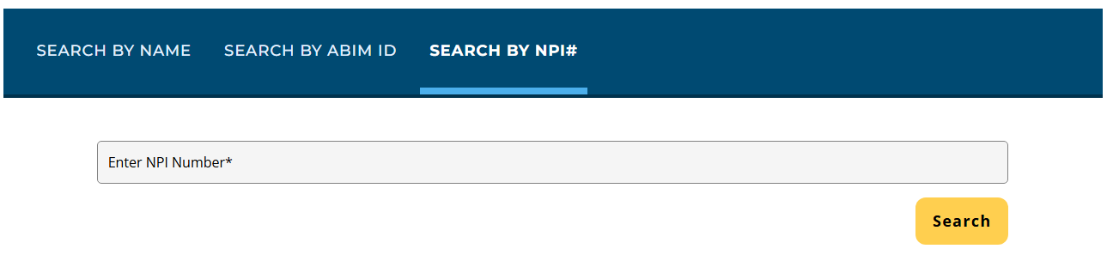
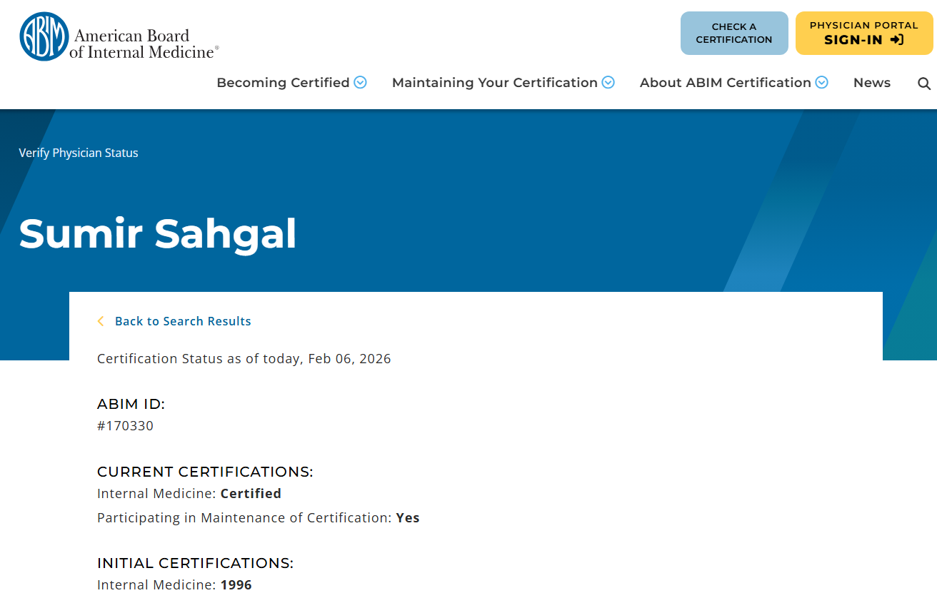

- For Physicians – ABFM (Family Medicine)
  - Go to: https://portfolio.theabfm.org/diplomate/verify.aspx
    - Enter the following:
      - First Name
      - Last Name
      - Social Security Number (last 4 digits)
      - Date of Birth (xx/xx/xxxx)
    - Click Verify
    - Screen grab the full page to include website with date and timestamp
      - Format: PDF
    - Scroll down and click View/Print Verification Letter Online
    - Save PDF into provider’s PCD folder
      - Name the file: Boards Verification ABFM exp xx.xx.xxxx
  - Add to provider checklist
    - Include:
      - ABFM Certification #
      - Status
      - Date verified
ABFM Boards Example Photos:
